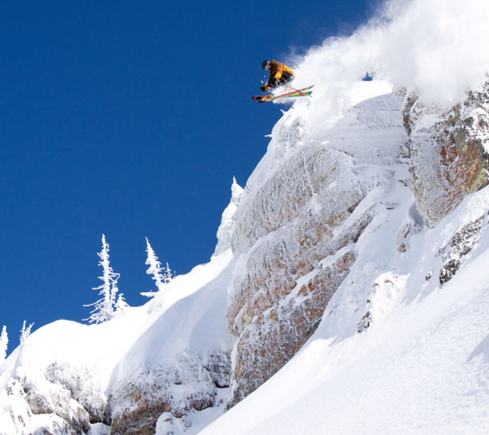

|  |
| --- |
| DATA REPORT  2020 |

|  |  |  |
| --- | --- | --- |
| Whitefish Mountain Resort |  |  |
| Email: whitefish@resort.com  Website: whitefishmountain.com | Tel: (123) 456-7890  123 Street, White, MT |  |

# report summary

This report was prepared by Christian Veater, Data Scientist.

## Findings

Data models were implemented to determine a strategy to recover the cost of the new chair lift system while maintaining current profit margins. Market data was taken from over 300 ski resorts in the United States with an array of variables to produce the best model. The focus was increasing the adult weekend/weekday price aligned with comparable resorts.

|  |  |
| --- | --- |
| Elevation Ranking Looking at how Whitefish Resort compares to other resorts in terms of vertical drop and summit elevation (magenta dot), we are considered slightly above average. Refer to  Figure 1.  Figure 1 Price Ranking In terms of pricing, Whitefish Resort is right on par with the adult weekday and adult weekend price correlation. Whitefish resort is considered to be a bit higher than most other | Figure 2  resorts @ $81 for an Adult weekend price. Refer to Figure 2. Days Open Ranking The projected days open vs the days open from last year is shown in Figure 3. Whitefish is showing a projected days open consistent with last year’s days open. We can plan on a similar season from last year for upcoming revenue calculations. This is confirmed in Figure 3. |
| Figure 3 Night Ski Ranking It has been observed that Whitefish ranks as one of the top night ski resorts in the country in terms of available acres. Comparing that feature to the adult weekend price, this would help justify an increased price.    Figure 4 Recommendations Based on market data supported by data modeling, it is advised that Whitefish resort increase the adult Weekend/Weekday price to $90. This increase will recoup the additional operating cost ($1.54 mil) of the new chair lift and maintain the current profit margin (9.8%). 175k adult visitors for the season (50% of total visitors) is to be assumed. |  |